Project Report Temp

1. Introduction

1.1 overview

* we work with global brands and business across the fashion

*creative a industries and fashion

* 1. purpose

* The use of this project what can be achieved using this establishment acts as a one stop destination servicing customers local

2. Problem definition & design thinking

2.1 Empathy map

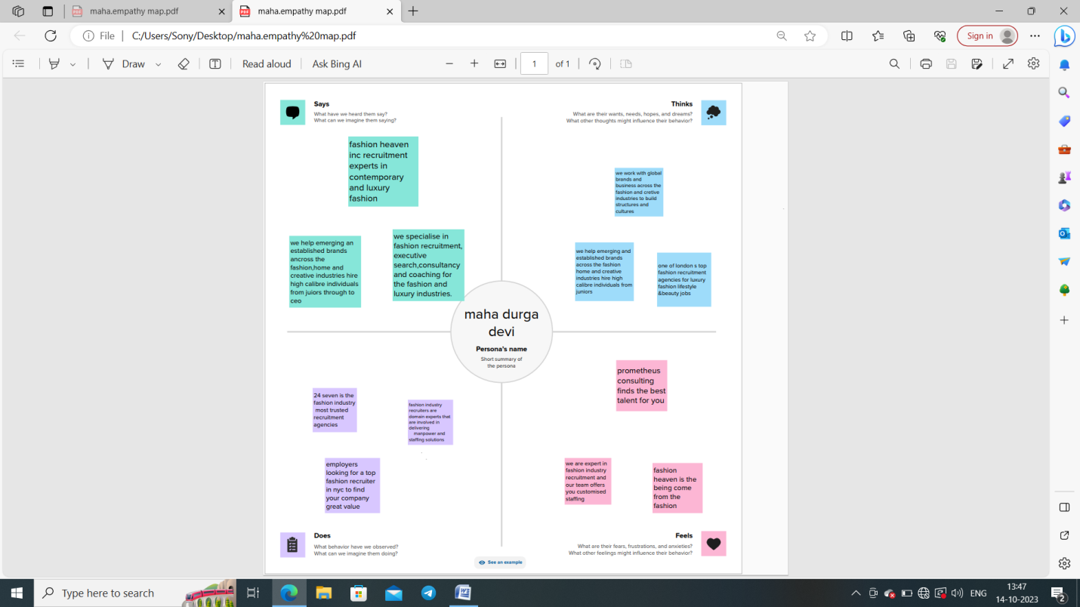

2.2ideation & brainstorming map

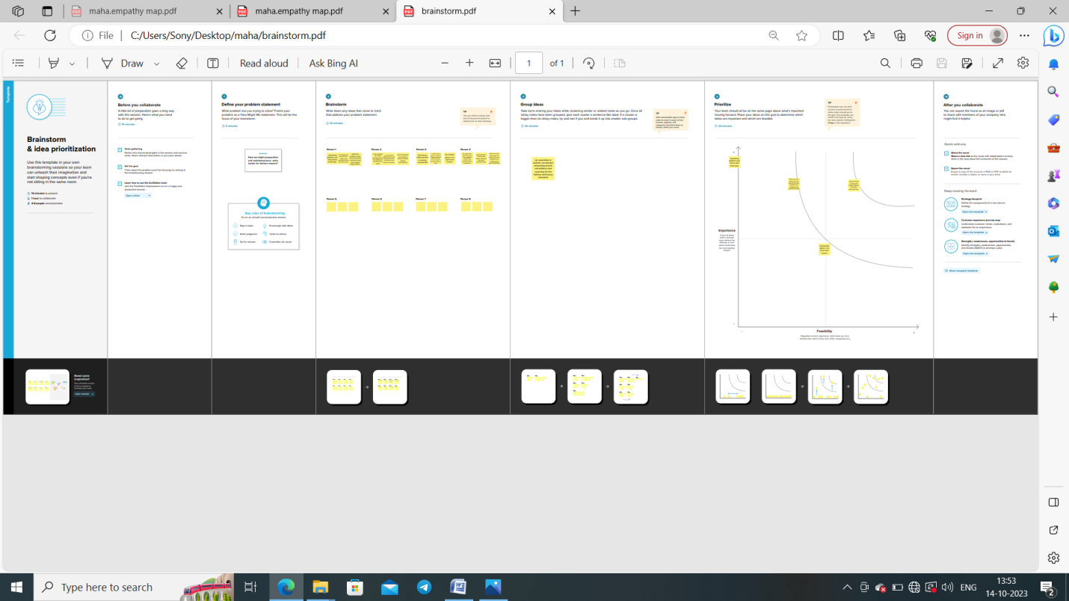

3. RESULT

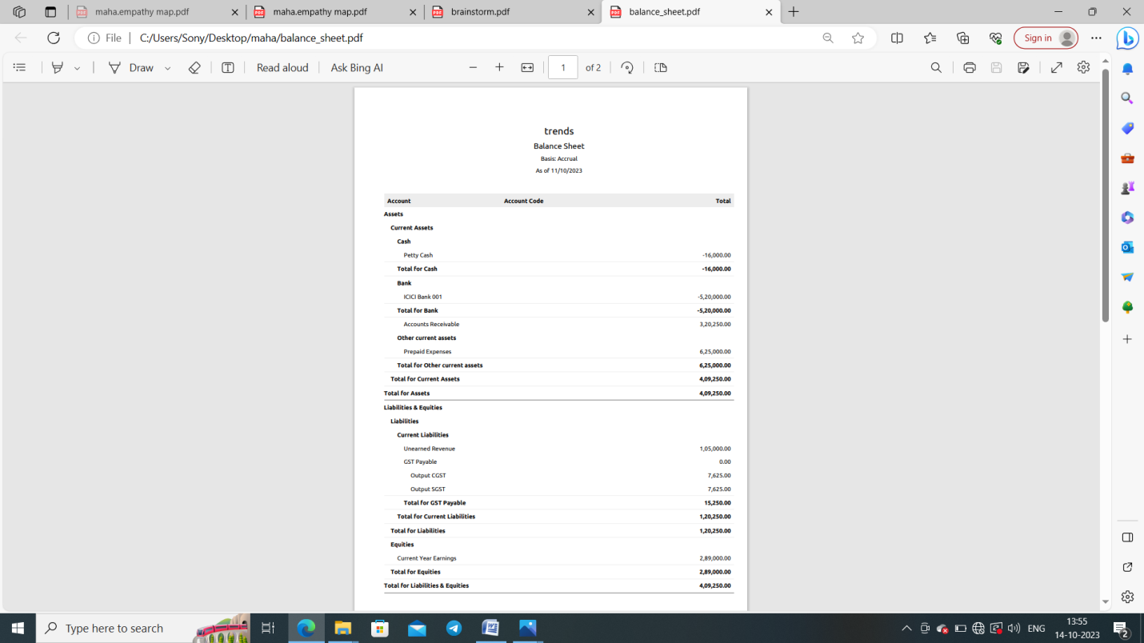

4. ADVANTAGES & DISADVANTAGES

* One of the greatest advantages of fashion is the development of your personality

* The people in your company get impressed by you and follow you as model.

5. APPLICATIONS

* Contact management online payments inventory management expenses

* zoho books is one stop platform for managing your accounting tasks and

Organizing your transactions

6. CONCLUSION

*It’s a platform and cloud based sevice for software development and version

*All the clearity of zoho books used by the project

7. FUTURE SCOPE

* They can join fashion houses,manufacturing , export units for a paid job or

Launch their own label in the market

*sustainability ,digitalization,personalization and customization

8. APPENDIX

https://github.com/maha-1789/preparation-and-maintenance-zoho-book-for-fashion-heaven_NM2023TMID22700